New MacBook Advertisement Risk Management
Mahmudul Alam
Colorado State University – Global Campus
Course Code: 20FA-CSC501-1
Dr. Charles Beverley
Tuesday, September 1, 2020
New MacBook Advertisement Risk Management
Every decision has a consequence. Once Newton stated, “for every action, there is an equal opposite reaction.” As a project manager we are faced with decision making daily. We must decide and it will have either positive or negative consequences. Risk management strategy can help us to make the best possible decision to maximize outcome for a project. According to Wiley, “Managing risks on projects is a process that includes risk assessment and a mitigation strategy for those risks. Risk assessment includes both the identification of potential risk and the evaluation of the potential impact of the risk.” Identifying the risk and evaluating it to have a better solution is the true purpose of risk management. We are releasing new MacBooks and advertising the new release nationwide with a slogan “MacBooks still don’t get viruses”, as a project manager I think there are many risks involved with the commercial. We might loose some old customers and might not get many new ones if we advertise an old feature of MacBook.
Project risk management is figuring out potential flaws or loose ends and the impact of those issues. Once the issues are evaluated finding a way to minimize the impact of the flaws is part of project risk management. There are many steps involved with risk management, according to Siegel, identifying the potential risks is the first step. Once the risk is identified, identifying the symptoms comes, once we know what is causing the issue, we need to measure the impact of that specific risk on our project. Creating mitigation and exploitation plans comes after. If the risk occurs, we should analyze the root cause and make sure it can be avoided for the next project. There are two different types of risk, first type is the Low-Likelihood and the second type is high-Impact events. We can have a matrix using these variables to measure the impact and the how likely something will happen to determine the best possible action and prioritize risk.
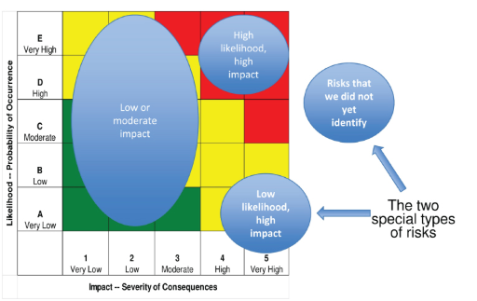
We can use this matrix to analyze every possible risk for our current project dealing with advertisement strategies releasing new MacBook. We will only deal with high likely hood and high probable risks. We can possibly loose customers, gain some customers advertising about invincibility of MacBook with viruses. Everyone is aware of security side of MacBook. Some people might ask what else is it offering? Some hackers might hack the system and it effect Apples revenue devastatingly. The probability of systems being hacked in high and it can have high impact on the brand companies’ revenue. Therefore, as a project manager I will write a report to the rest of the team why should not we go with this advertisement.
There can be many factors and variables associated with risks. To develop projects, we can have financial risk, some feature might take more investment developing a then the potential revenue. We might face social issues within the company or outside of the company developing certain features which might cause social issues. Its often technical risks are involved completing a module.Defining a clear way to address risk for each module or features for the project can help us to gain better understanding of oval risk involved developing each section of the project and address them better. According to KAYA,
“In England, each hospital defines its own risk matrix to be used in risk assessment, which includes the assessment of clinical, organizational, health and safety, and financial risks (NPSA, [39]). Risk matrices are embedded into the organizational risk register system that each hospital member can access and register a risk. A risk matrix can help to visualize and prioritize a range of risks that are reported by different individuals”.
We need to create a risk matrix for all the potential advertisement for our new MacBook release and have multiple analysis of the matrix before we come to a final strategy for the advertisement. Advertising team has decided to go with the tried-and-true slogan that MacBooks still don't get viruses. As a project manager I suggest killing this advertising strategy. MacBook has been out there in the market for years and most people knows about the security features of it, we should promote the new release with some new feature of the MacBook, fingerprint, touchscreen, Virtual capabilities. If we do not promote the new feature, we might be under financial risk with the product
Conclusion
Identifying and evaluating potential impact of the risks using a risk matrix chart appropriate for the project is risk management. As a project manager for new MacBook I am against the advertisement using the signature slogan for MacBook, about its resistance to virus. We have financial and technical risk involved with that approach. We should promote new high tech features for the MacBook to have the best possible outcome for our new project.

References
Siegel, N. G. (n.d.). Engineering Project Management. Retrieved from https://platform.virdocs.com/r/s/0/doc/712839/sp/74525076/mi/315256850?cfi=%2F4%2F2%2F8%2F12&menu=search&q=statement%20in%20%20
Wiley, & Al., E. (n.d.). 11.2 Risk Management Process. Retrieved August 21, 2020, from https://pm4id.org/chapter/11-2-risk-management-process/ (Links to an external site.)
KAYA, G. K.; WARD, J.; CLARKSON, J. A Review of Risk Matrices Used in Acute Hospitals in England. Risk Analysis: An International Journal, [s. l.], v. 39, n. 5, p. 1060–1070, 2019. DOI 10.1111/risa.13221. Disponível em: http://search.ebscohost.com/login.aspx?direct=true&db=bth&AN=136151046&site=eds-live. Acesso em: 1 set. 2020.

